**Arielle Zhivko**

**Sub-Main Curator**

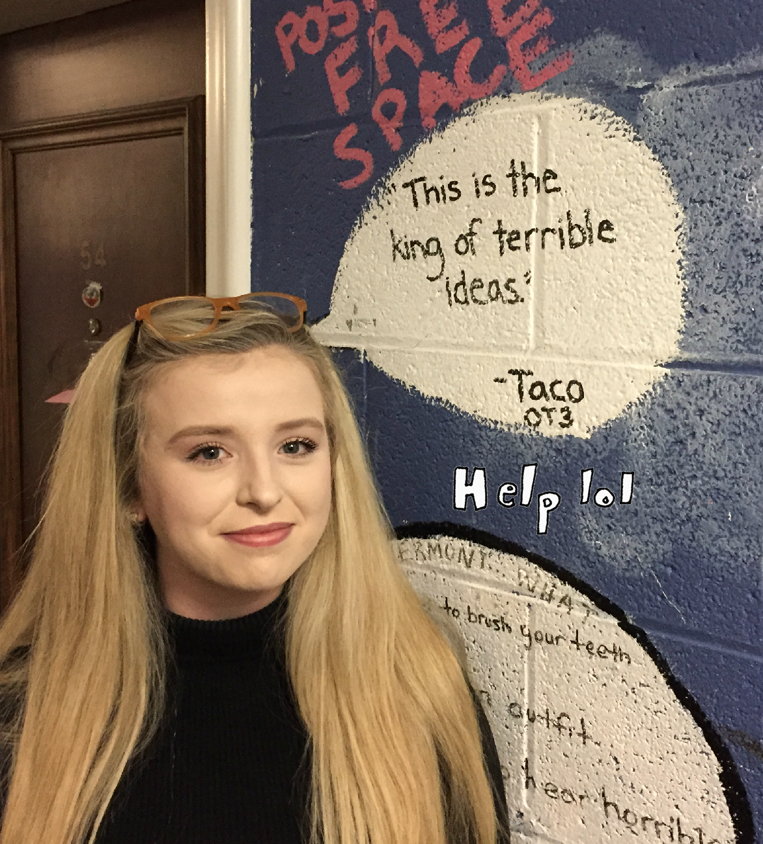

Members of College,

As many of you of know I live in the basement. Since coming to Trinity College, I’ve basked in the luxurious atmosphere that is the crypt of St. Hilda’s College Aka Sub-Kirk. Few people are fortunate as I to have been blessed with residing in an area filled with anti-socialites, atrocious graffiti and no common room. It is for this reason that I believe I am the best selection for Sub-Main Curator.

My time in Sub-Kirk has made me recognize how integral social spaces are to this college. For those living in less social areas, Sub-Main has the unparalleled potential to be an area for more social students to gather without having to leave St. Hilda’s.

In this position, I hope to address the awareness surrounding Sub-Main. It was well into the new year before many first-year students realized they could utilize this space. If elected, I would work on extending its hours of usage. Given its location, the room can double as a study space and so it seems impudent to remove students before midnight. Additionally, improving its lackluster atmosphere is one of my main goals. Acquiring funds for this area in an effort to revamp it and providing the room with a well needed clean-up, a new coat of paint and furniture are paramount.

Given my experience with this area of St. Hilda’s and my expertise regarding its residents, I would be grateful for the opportunity to Martha Stewart the heck out of Sub-Main.

Met’agona,

Arielle Zhivko